Finally, the perfect roommate
The Sennheiser AMBEO Soundbar Mini brings immersive audio technology to even the cosiest of spaces

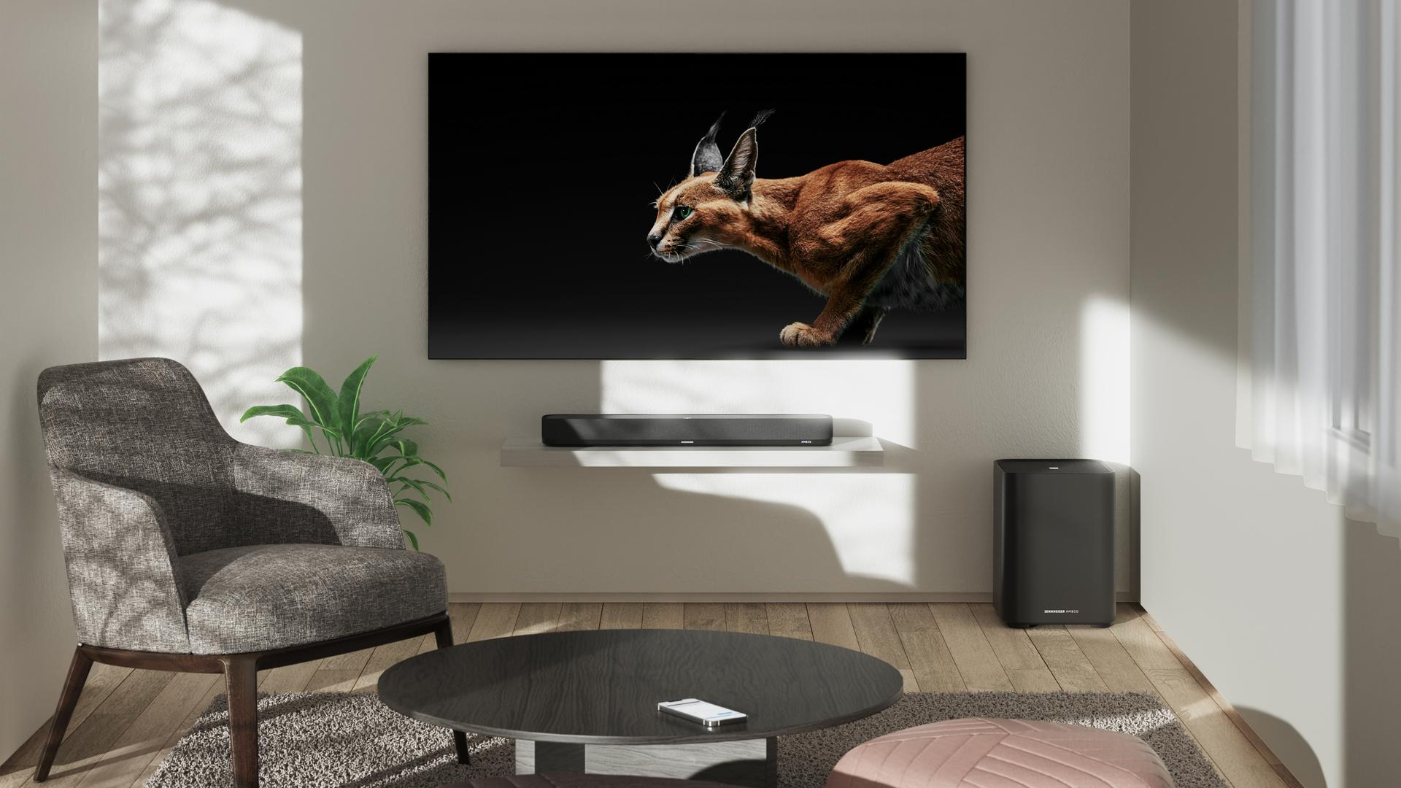Pictured: the AMBEO Soundbar Mini and optional wireless AMBEO Sub

Marlow, UK – August 31, 2023 – The German audio brand’s award-winning AMBEO Soundbar experience is now available in a new versatile size: the Sennheiser AMBEO Soundbar Mini. With a sound that punches well above its weight and up to 7.1.4 virtualisation, the latest addition to the spatial audio Soundbar family readies even the smallest of spaces for three-dimensional acoustics.

“The magic of Sennheiser AMBEO technology immerses consumers in stunning 3D sound from a simple, single source in practically any home entertainment space,” says Maximilian Voigt, Sennheiser AMBEO Soundbar Product Manager. "Our most compact Soundbar yet comes at the perfect time with both features and dimensions that are a joy to live with, in or out of the living room.”
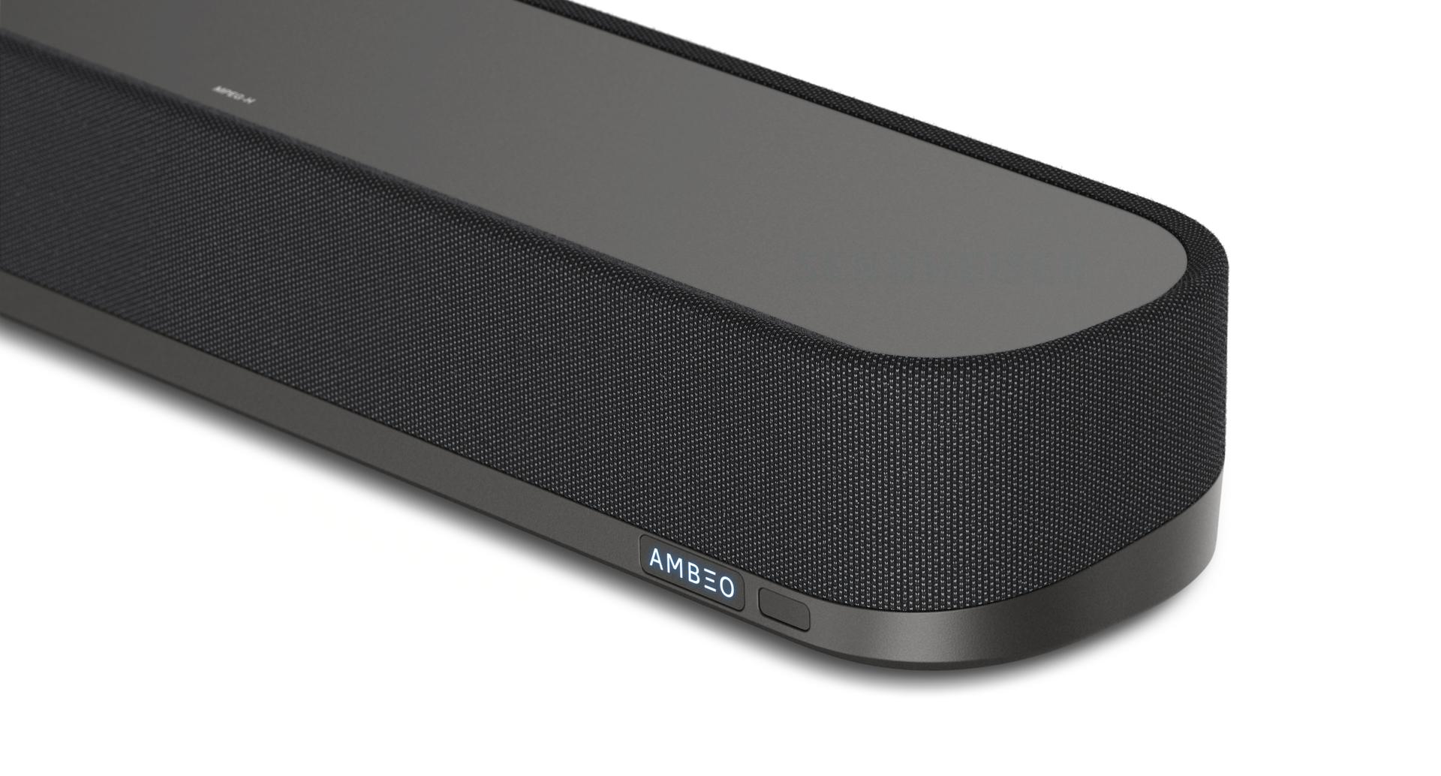
Pictured: closeup of the AMBEO Soundbar Mini
A fun-size bar
At less than half the cubic volume of its Soundbar Plus sibling, it’s easy to see why the Sennheiser AMBEO Soundbar Mini appeals to audio lovers looking to upgrade a current living room, desktop, bedroom, or even game room setup. At just 70 x 10 x 6.5 cm in size, it blends into nearly any TV or monitor arrangement, yet stands out with its cutting-edge acoustics. There are 250 watts of ultra-clean class D amplification powering four high-end full-range drivers and dual four-inch subwoofers, so consumers can expect the sharp fidelity, impactful bass and crystal-clear presence that make its bigger relatives a hit with audio critics.

Other useful audio modes personalise the listening experience, including content-specific presets, a voice enhancement option and neighbour-friendly night mode. Ease of use is at the heart of the Mini, with an HDMI¹ input that accommodates a wide range of eARC-enabled TVs or monitors. Integration with the Sennheiser Smart Control App makes management of features and updates from your smartphone a breeze.

Those who know, AMBEO
Like its larger siblings, the Sennheiser AMBEO Soundbar Mini’s 3D sound is the result of a collaboration with the Fraunhofer Institute for Integrated Circuits IIS² —a world leader in audio research and development. The Mini has four integrated microphones that serve a dual purpose: they function as the central component of the AMBEO room calibration, and facilitate Alexa³ voice assistant commands as the Soundbar features Alexa Built-In. Consumers also have the option to utilise existing Google Assistant⁴ or Siri-enabled devices to cast audio to the Mini through Chromecast Built-In™ and AirPlay®⁵, respectively.

As with all AMBEO Soundbars, the native AMBEO|OS operating system allows for one-touch calibration that scans the room, adjusting the surround virtualisation to account for various room sizes, reflections, and textures. Further, the Mini supports popular Dolby Atmos®, DTS:X™, MPEG-H codecs, and 360 Reality Audio6 formats and experiences for enjoying native spatial audio content. A wide-ranging support of digital music services also makes the Mini a great streaming companion over Wi-Fi or Bluetooth® with vibrant, room-filling sound and impactful bass—all the way down to 43 Hz—from your favourite streaming services such as a Spotify®, TIDAL, Amazon Music, and Apple Music®. AMBEO|OS seamlessly integrates the Mini into popular content ecosystems as a Spotify Connect, TIDAL Connect, and AirPlay 2 device. Bass lovers can add even more low-end punch with wireless connection to as many four Sennheiser AMBEO Subs (sold separately). 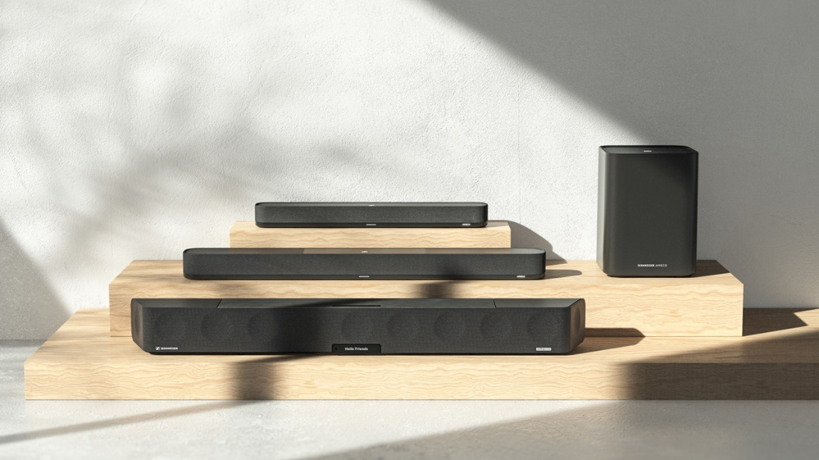

Pricing and availability
The Sennheiser AMBEO Soundbar Mini will be available to order at sennheiser-hearing.com and select retailers on September 1st, with an RRP of £699 / €799. For more information, visit sennheiser-hearing.com.

[1] The terms HDMI, HDMI High-Definition Multimedia Interface, and the HDMI Logo are trademarks or registered trademarks of HDMI Licensing Administrator, Inc.
[2] upHear and MPEG-H technology licensed by Fraunhofer IIS. www.iis.fraunhofer.de/audio
[3] Subject to regional availability and language. Amazon, Alexa and all related marks are trademarks of Amazon.com, Inc. or its affiliates
[4] Google, Google Home and Chromecast built-in are trademarks of Google LLC. Google Assistant is subject to regional availability
[5] Apple and AirPlay are trademarks of Apple Inc., registered in the U.S. and other countries and regions
[6] 360 Reality Audio is an immersive music experience that uses Sony’s object-based 360 Spatial Sound technology and is a trademark of Sony Corporation
All other product names and services may be trademarks of their respective owners

About the Sennheiser brand
We live and breathe audio. We are driven by the passion to create audio solutions that make a difference. Building the future of audio and bringing remarkable sound experiences to our customers – this is what the Sennheiser brand has represented for more than 75 years. While professional audio solutions such as microphones, meeting solutions, streaming technologies and monitoring systems are part of the business of Sennheiser electronic GmbH & Co. KG, the business with consumer devices such as headphones, soundbars and speech-enhanced hearables became part of the Sonova Holding AG group of companies in 2022, who have licensed the Sennheiser trademark for this purpose.

www.sennheiser.com
www.sennheiser-hearing.com

About Sonova Consumer Hearing
Sonova Consumer Hearing offers premium headphones and hearables – primarily in the true wireless segment – as well as audiophile headphones, hearing solutions and soundbars under the Sennheiser brand. The business is part of the Sonova Group, a global leader in innovative hearing care solutions with headquarters in Switzerland and more than 17,000 employees worldwide.

Press contact

Milan Schlegel
PR and Influencer Manager Consumer – EMEA Sennheiser Consumer Audio GmbH
milan.schlegel@sennheiser-ce.com
T +49 (0)5130 600 1139

Sennheiser UK&I PR agency
sennheiser@harvard.co.uk

